**Arithmetic Operator Example:**

#include <stdio.h>

int main() {

int a, b, sum;

printf("Enter first number: ");

scanf("%d", &a);

printf("Enter second number: ");

scanf("%d", &b);

sum = a + b;

printf("Sum is: %d\n", sum);

return 0;

}

**OUTPUT:**

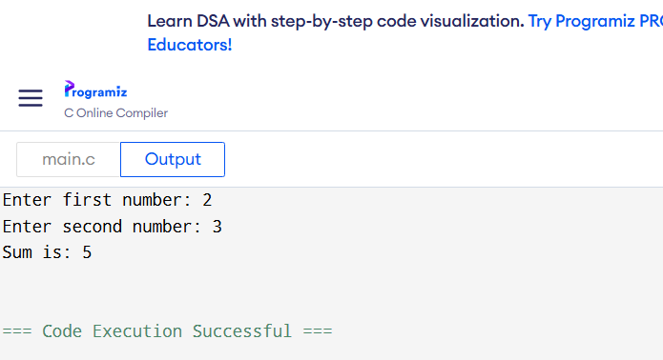

**Comparison Operator Example**

#include <stdio.h>

int main() {

int x;

printf("Enter a number: ");

scanf("%d", &x);

if (x > 0) {

printf("Positive number\n");

} else {

printf("Zero or negative number\n");

}

return 0;

}

**OUTPUT:  
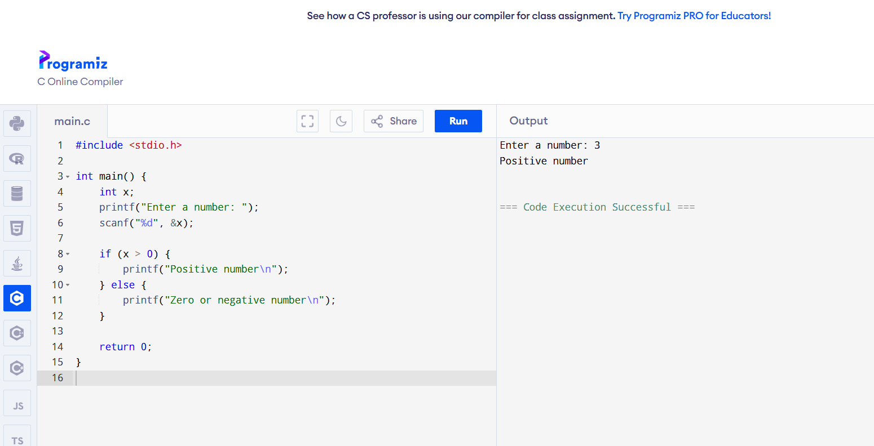**

**Logical Operator Example**

#include <stdio.h>

#include <string.h>

int main() {

int age;

char citizen[10];

printf("Enter your age: ");

scanf("%d", &age);

printf("Are you a citizen (yes/no)? ");

scanf("%s", citizen);

if (age >= 18 && strcmp(citizen, "yes") == 0) {

printf("Eligible to vote\n");

} else {

printf("Not eligible to vote\n");

}

return 0;

}

**OUTPUT:**

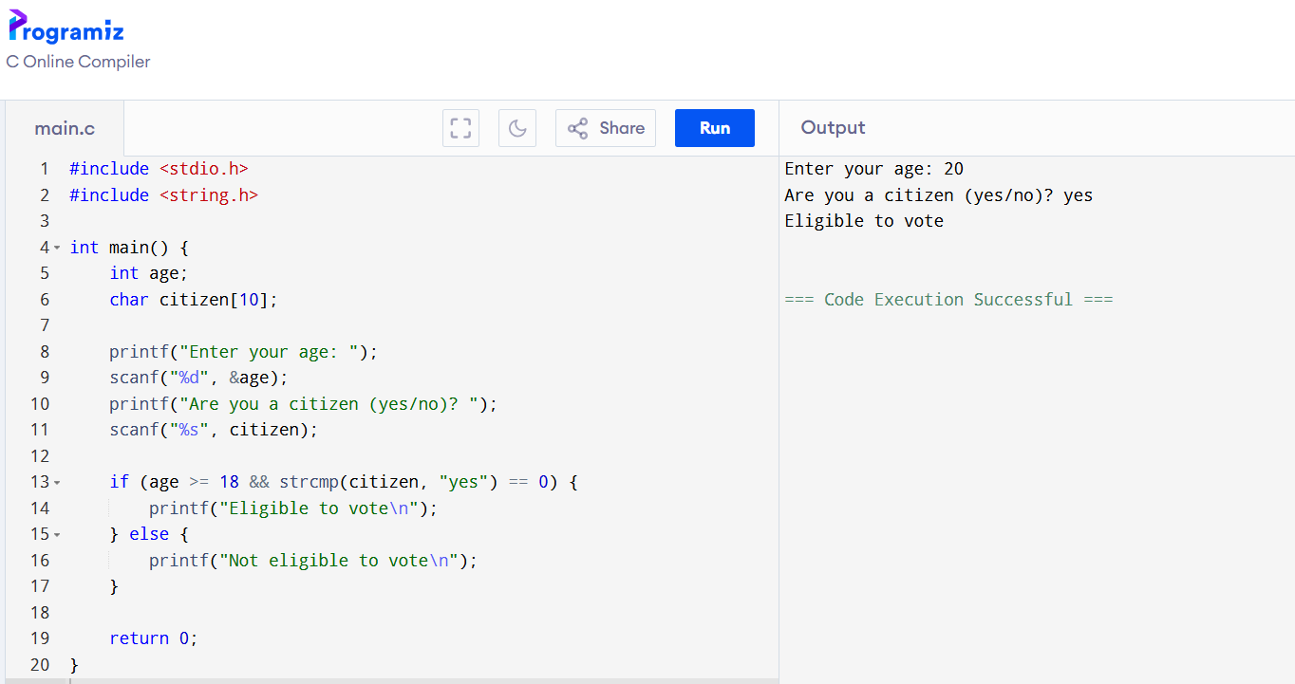

**Assignment Operator Example**

#include <stdio.h>

int main() {

int x = 5;

x += 3; // x = x + 3

printf("Updated value of x: %d\n", x);

return 0;

}

**OUTPUT :**

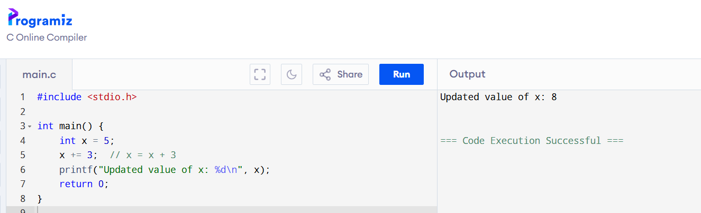

**Expression with Multiple Operators**

#include <stdio.h>

int main() {

int a, b, result;

printf("Enter value of a: ");

scanf("%d", &a);

printf("Enter value of b: ");

scanf("%d", &b);

result = (a + b) * (a - b);

printf("Result of expression (a + b) * (a - b) is: %d\n", result);

return 0;

}

**OUTPUT :**

